Welcome Students to the NAO Experience

The Basics of NAO

NAO is a humanoid robot that each of you will teach to navigate and pick up objects in the environment. This will be done through coding, but not in the traditional sense. It will be done through the use of blocks that connect together like Legos. These pieces can be dragged onto the board and combined to allow the robot to complete the actions on the individual pieces in order from top to bottom. A picture of the home screen is shown below:

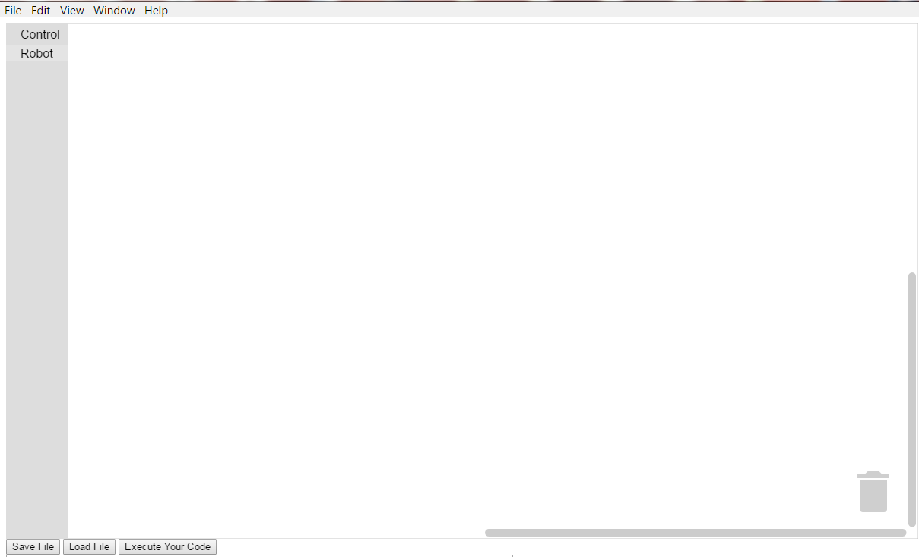
Figure 1: The Main Screen

The first step in getting the robot to listen to our instructions is grabbing the code blocks from the side bar. For now the only blocks that we will use are under the Robot section so click on that. A selection of blocks should now be visible as shown below:

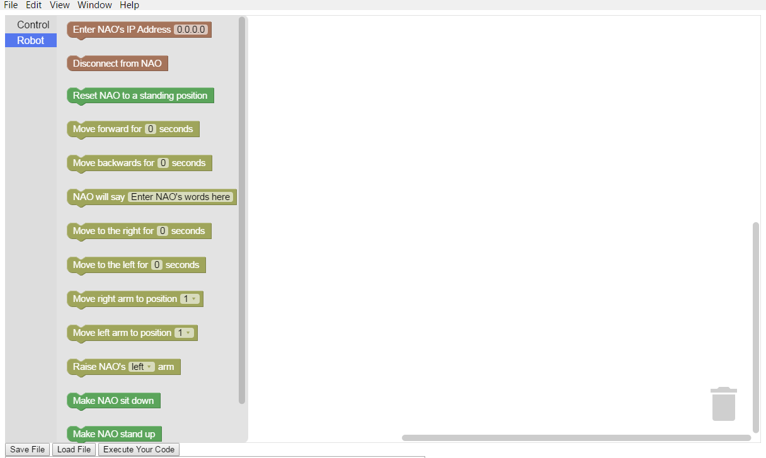
Figure 2: Basic Code Block Selection
Now we want to right click on the “Enter NAO's IP Address 0.0.0.0” block and drag it onto the white work space to the right of the selection area as shown below:
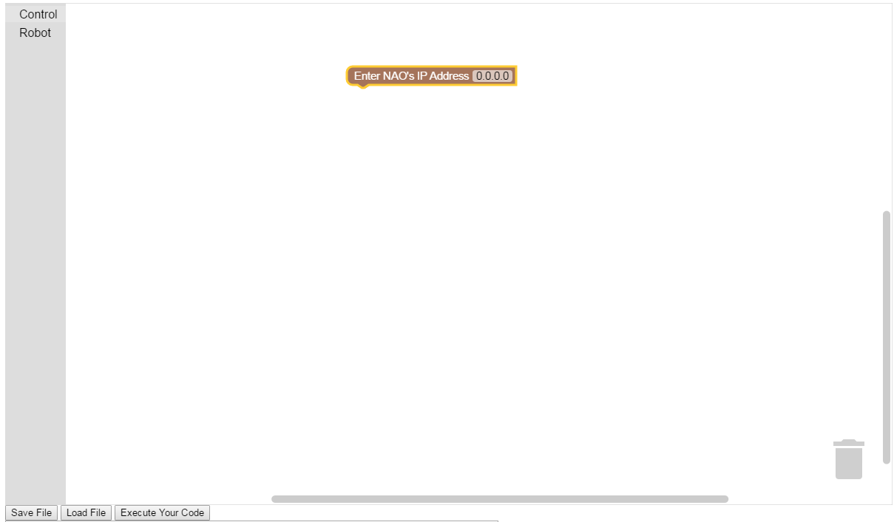
Figure 3: Placing the First Block

Next click on the 0.0.0.0 and change it to the numerical value provided by your instructor. (Note: This value can be found be pressing the center button on the NAO system and inputting the spoken IP address) Once this has been done reopen the robot section once again and grab the “Reset NAO to standing position” block and drag it just below the IP address block that was placed before. It should click into place forming one solid block as shown below:
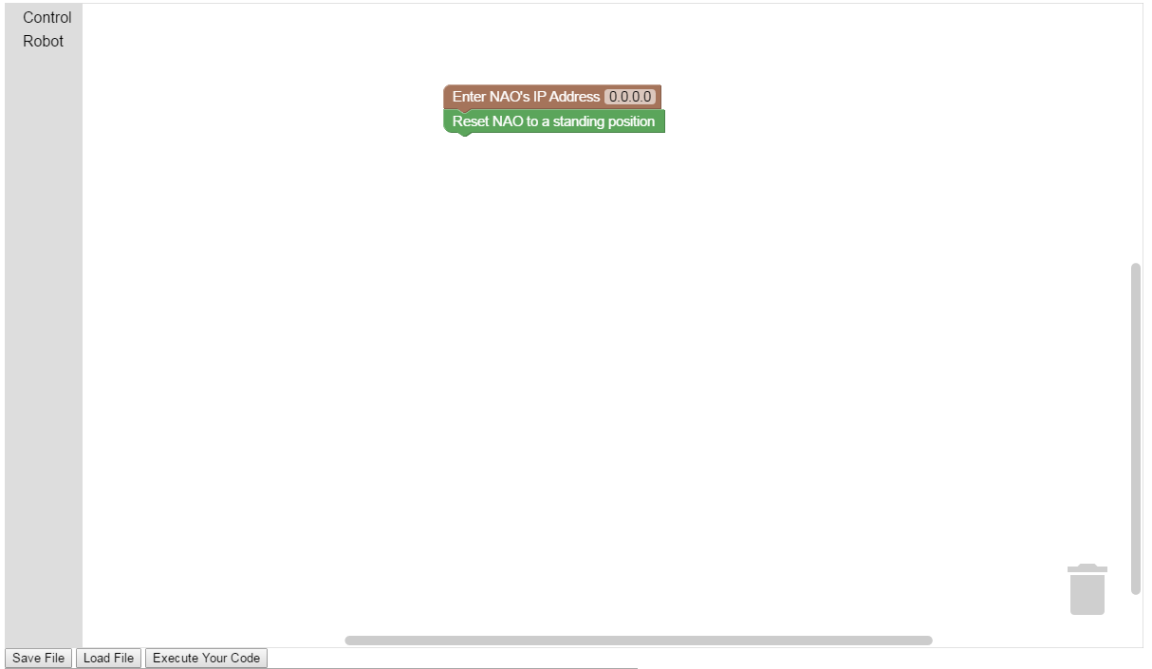
Figure 4: Connecting Blocks Together
Now right click on the “Execute Your Code” button in the lower left of the screen. The robot should now stand up! These two blocks should always be at the start of your code. This ensures the robot is in a safe position to execute the code and is properly connected to the computer. Now add the “Move forward for 0 seconds” block. Edit this to be 3 seconds by clicking on the 0 in the block just as was done for the IP Address block. The code blocks should now look like the structure shown below:
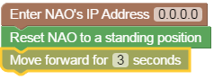
Figure 5: Sample Coding Instructions
Run this code the same way as before by pressing the “Execute Your Code” button. The robot should now be walking forward! Now try to make the robot move in a square. Look at the blocks in the Robot section as before. You already know how to move the robot forward now just do the same thing for left, backward, and right to form a square. A solution is shown below:
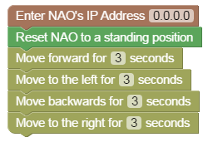
Figure 6: Square Solution
Execute the code and watch as the NAO moves in a square, returning back to its original position at the end. Now lets suppose we want to know when the robot has completed the task. We can do this by having the robot speak! This can be done by grabbing the “NAO will say” block and placing it at the end of our code. Now click on the Enter NAO's words here and type Mission Complete. The block should now look as follows:
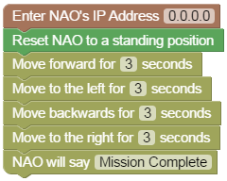
Figure 7: Speaking Solution
Execute the code as before as listen as the robot exclaims its completion of the previously created square movement code! Now on the the last part of this lesson that will teach the concept of loops!
Now create a series of code blocks that has the robot walk forward for 3 seconds and then go left for 3 seconds. Execute this code as before to ensure this code works as intended. Now try the make the robot do this same series of actions a total of 3 times rather than just once. One solution to this is shown below:
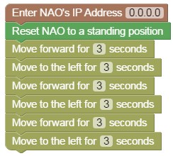
Figure 8: Non-Looping Method
This method is time consuming as each block needs to copied and placed for each time it needs to be done by the NAO robot. However, there is a much more elegant way to do this that can produce the same result with less blocks. The method used to do this is called looping. Loops do exactly what the sound like they loop. They run through a series of code blocks a set number of times and then proceed to the remainder of the program. In order to use this new method a new type of block is needed, a Control block. Select the Control section above the robot section we have used previously. A new set of blocks should be available now as shown below:
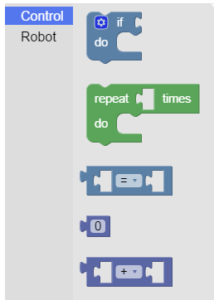
Figure 9: Control Blocks
Grab the green repeat block from this list of blocks. Place it below the reset function and place a single move forward 3 seconds and move left 3 seconds block in the center section of the block next to “do”. An example is shown below:
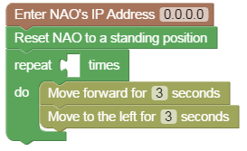
Figure 10: Placing the Loop Block
The final step is filling in the hole next to repeat. The section determines how many times the robot is to execute the blocks in the “do” portion. In this case moving forward 3 seconds and the left for 3 seconds. In order to fill this in go back to the Control section and select the 0 block shown below:
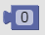
Figure 11: The Number Block
Now place this in the remaining hole next to repeat. Edit it as was done with the previous blocks to read 3 instead of 0. This will make it run 3 times which is exactly what the goal is. Now add speech block below the entire block and have the robot say “Lesson Complete” and execute the code. Watch as the robot will cycle through the commands 3 times and then speak. This may only be a small improvement over the previous example for running 3 times, but now imagine trying to run this 10 times or 100! This would make the original method take a very long time to do as each block would have to be placed 100 times! However, with this new method the number of blocks doesn't change. All that needs to be altered is the blue number block to 100!

Congratulations on Completing the Lesson!

